**Saffron Stays Project Documentation**

**1. Title**

**Saffron Stays: Where Tranquillity Meets Luxury in Every Stay**

**2. Description**

**2.1 Overview**

Saffron Stays is a hotel booking system designed to provide users with a seamless experience for booking luxurious stays. The platform offers a user-friendly interface, ensuring that customers can easily search for, book, and manage their reservations. With a focus on tranquillity and luxury, Saffron Stays aims to be the go-to platform for discerning travellers seeking exceptional accommodations.

**2.2 Key Features**

**User Registration and Login:** Users can create an account and log in to access their personalized dashboard.

**Hotel Search and Booking:** Users can search for hotels, view details, and book rooms based on availability.

**Admin Panel:** Admins can manage hotel listings, bookings, and user accounts.

**Real-Time Availability:** The system ensures that room availability is updated in real-time, preventing double bookings.

**Secure Payments:** Integration with secure payment gateways for hassle-free transactions.

**Responsive Design:** The platform is optimized for use on desktops, tablets, and mobile devices**.**

**3. Participants and Their Respective Roles**

**Project Team**

**Kareti Pujitha:** Project Manager and Backend Developer. Responsible for overseeing the project development and implementing the backend services using Spring Boot.

**Rishi Vasan: Frontend Developer.** Worked on designing and implementing the user interface using React.

**Sindhu koratla: Database Administrator.** Managed the MySQL database, including schema design and optimization**.**

**Sai Kumar Karumanchi: QA Engineer.** Conducted thorough testing to ensure the application is bug-free and meets the quality standards.

**Hotels data we used:******

**4. Screenshots Demonstrating the Execution of the Application**

**Home Page:**

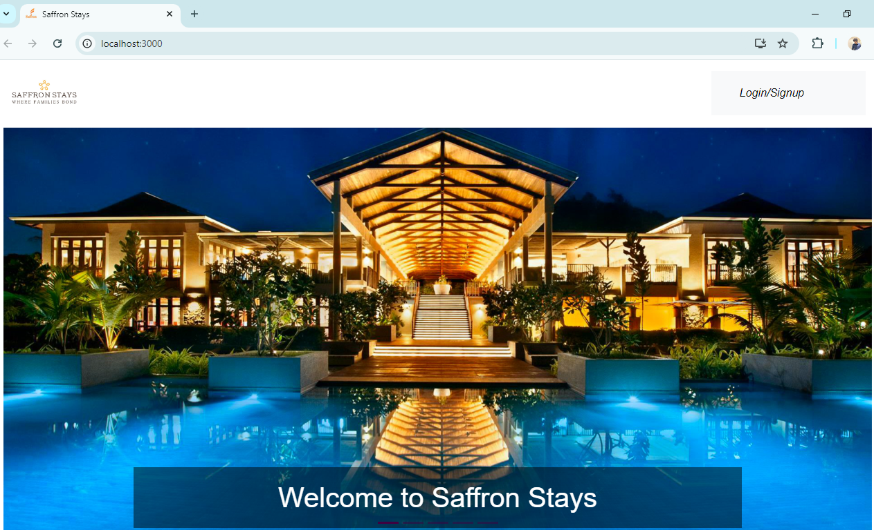

**Login Page:**

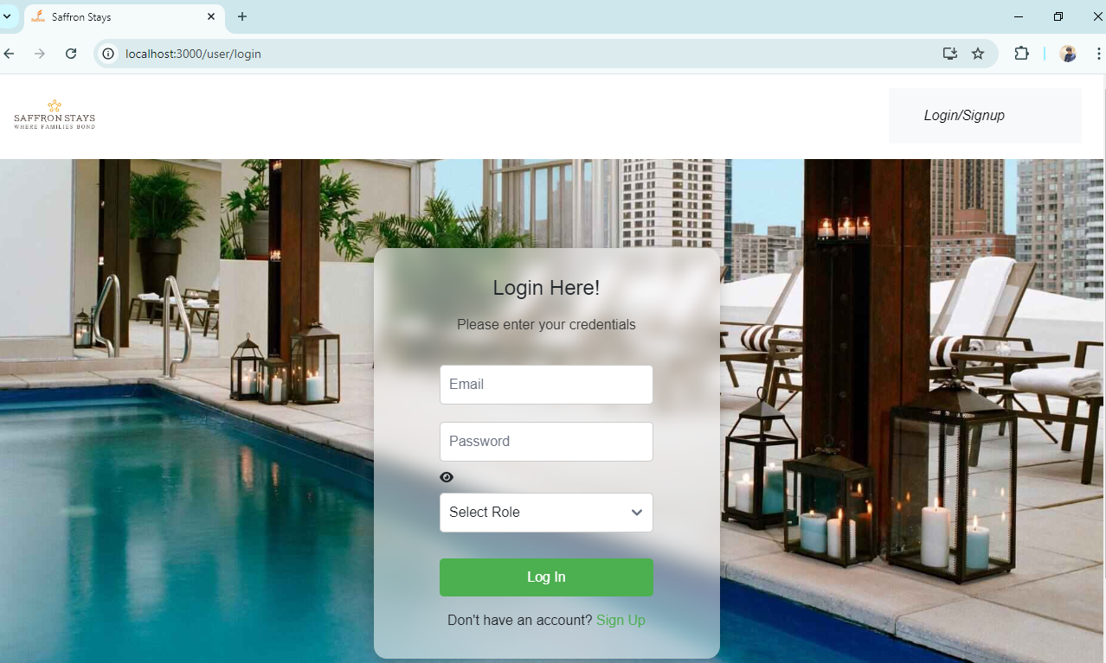

**SignUp Page:**

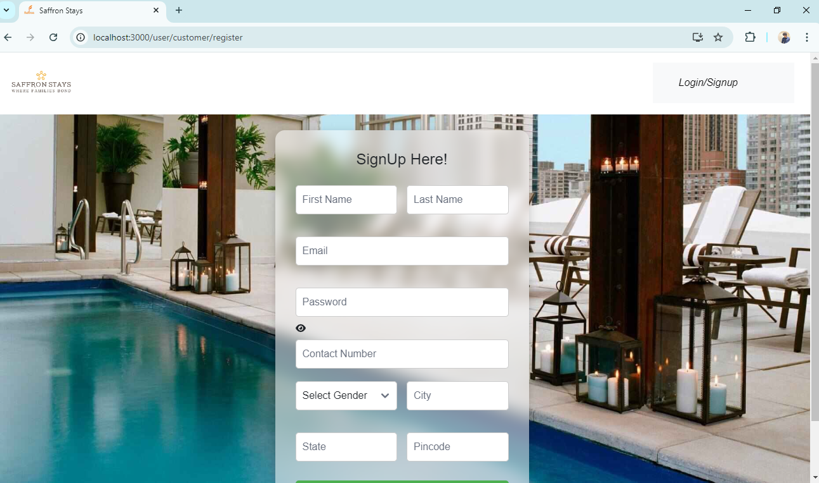

**Admin Dashboard:**

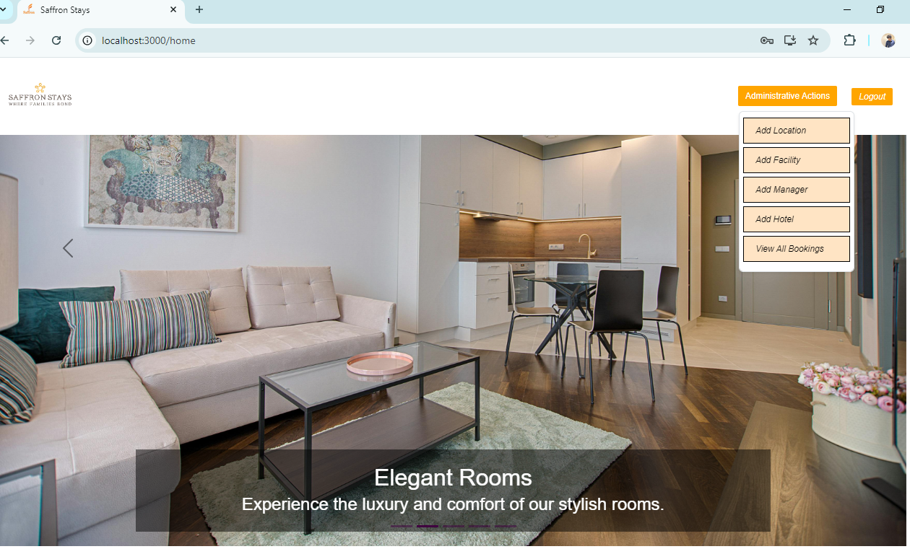

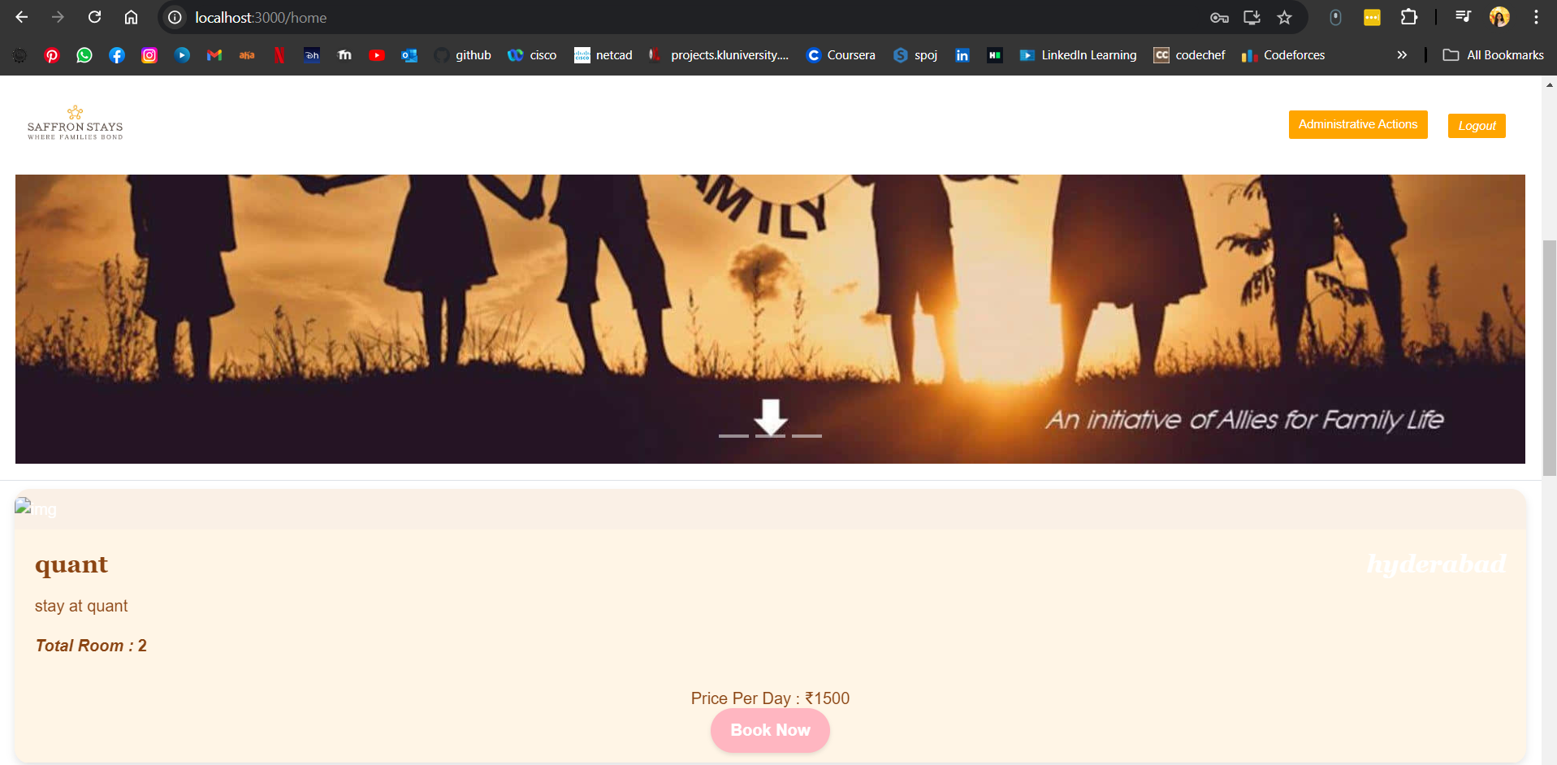

**Add Location:**

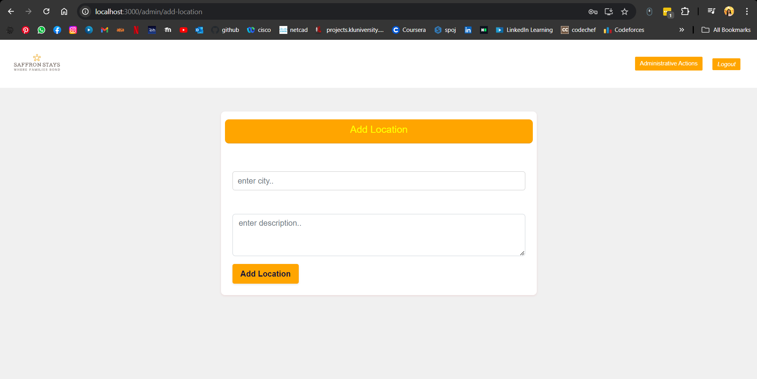

**Add Facility:**

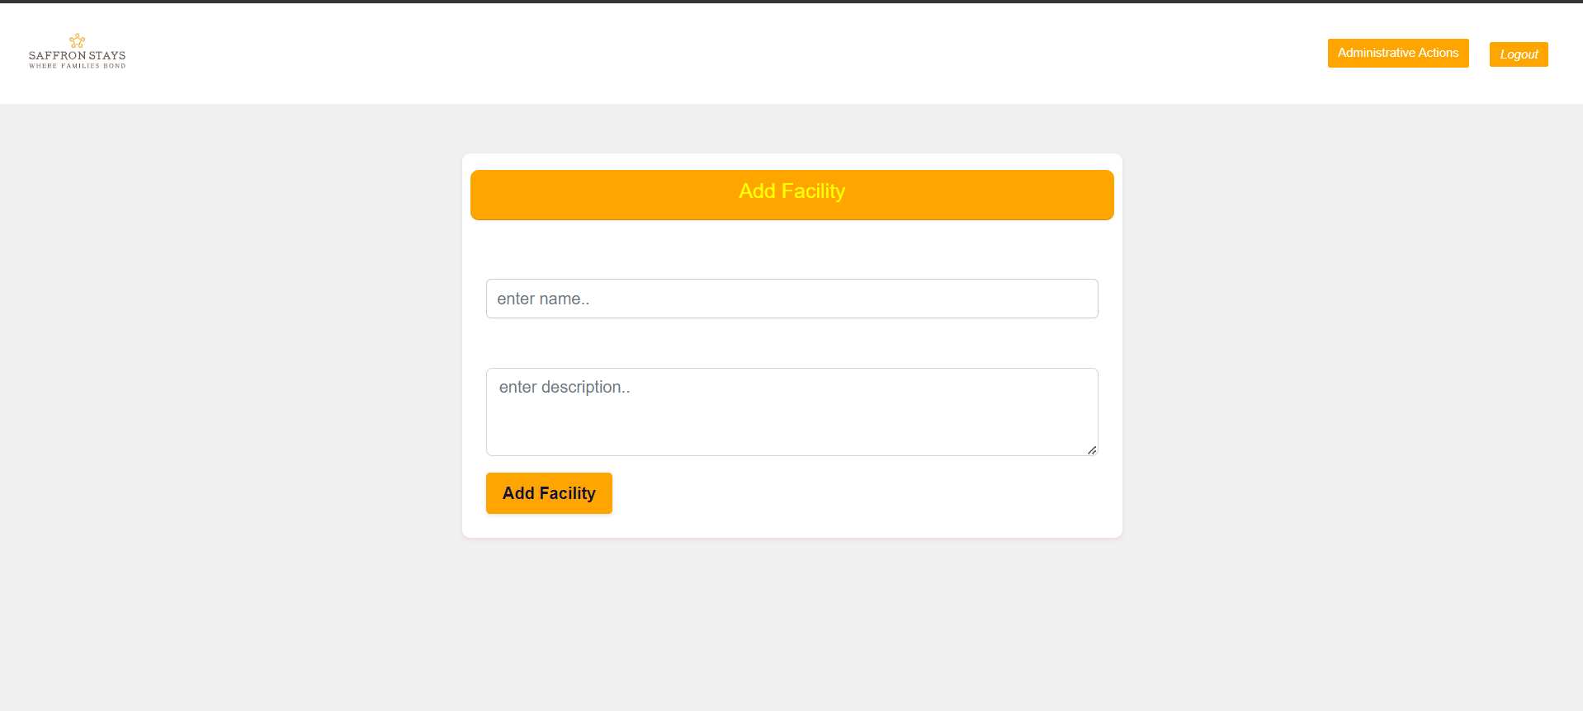

**Customer dashboard:**

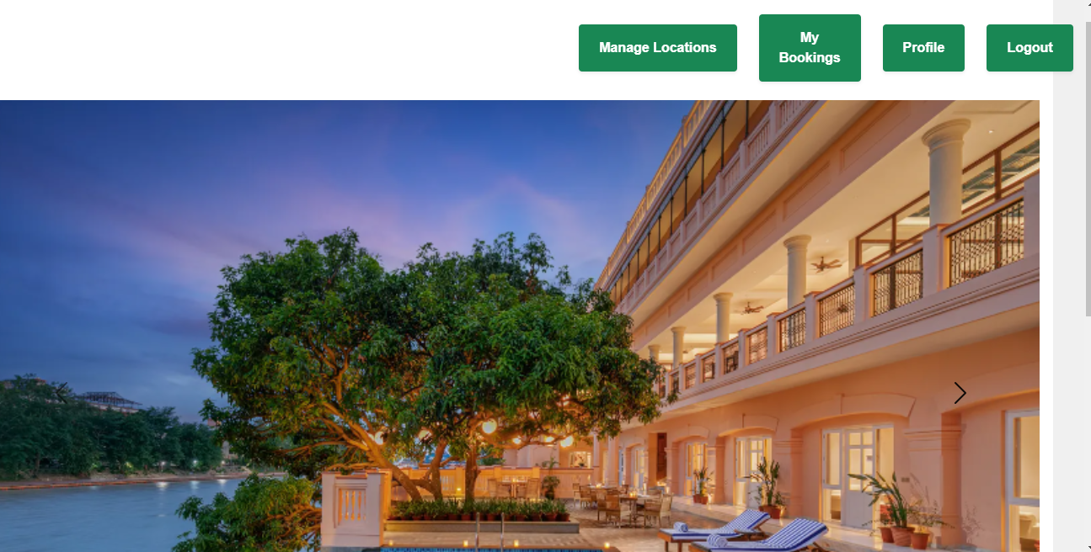

**Add Review page:**

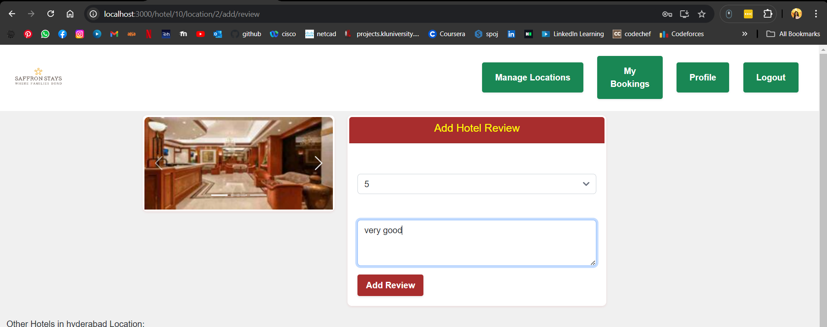

**Book hotel:**

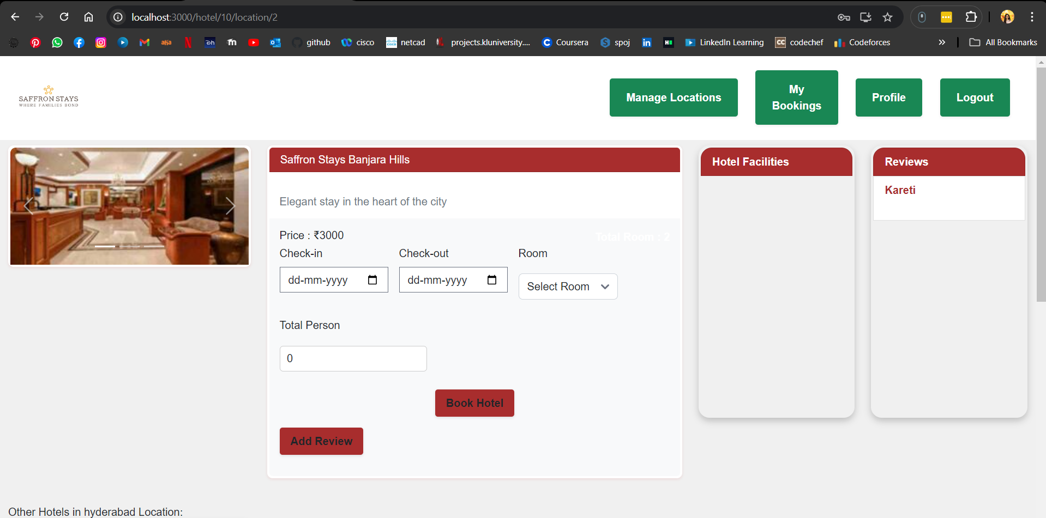

**Pop up of booking hotel:**

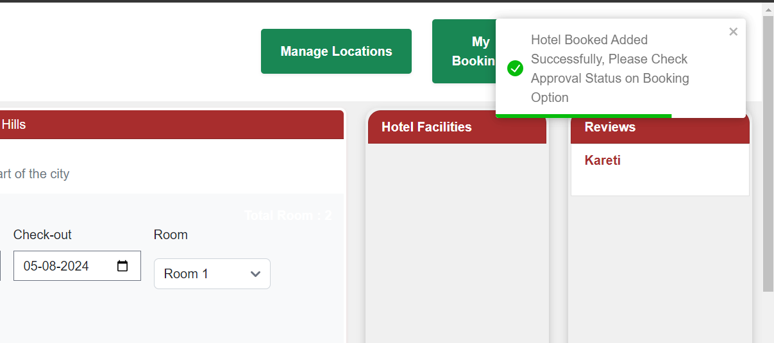

**Mysql Data:**

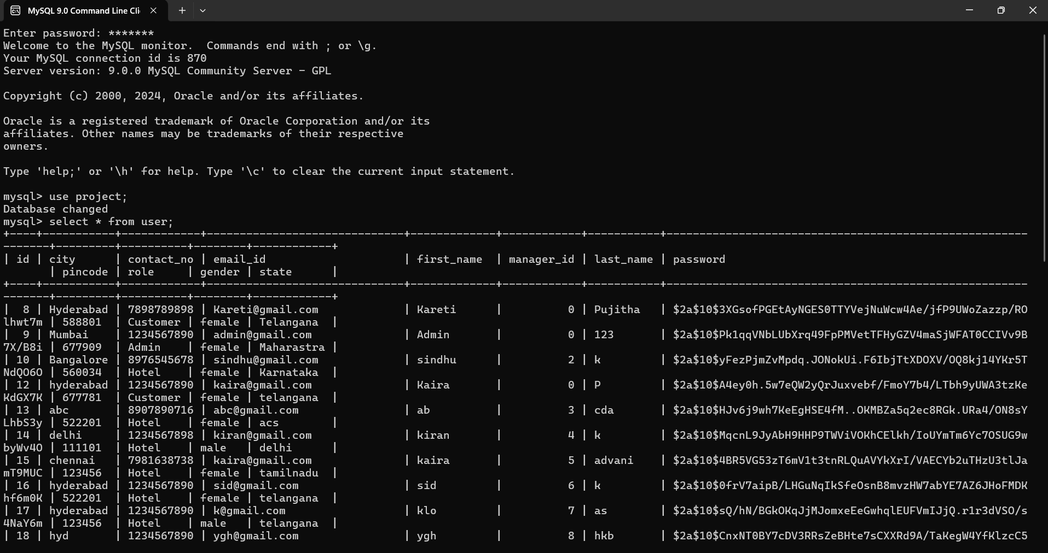

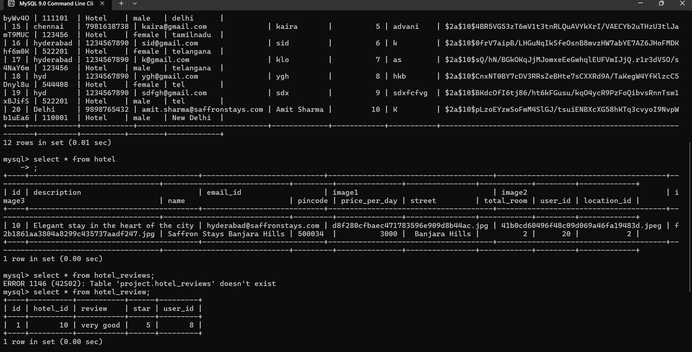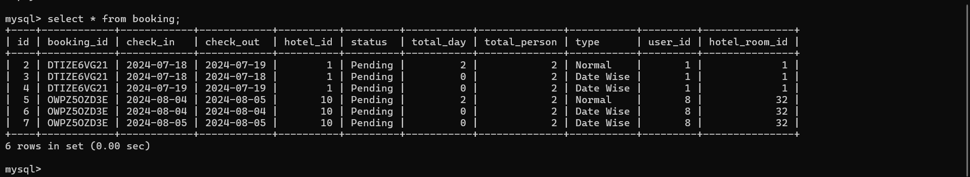

**5. GitHub Link**

You can find the complete source code for both the frontend and backend of the Saffron Stays project in the following

**GitHub repository:**

**https://github.com/karetipujitha/Saffron-Stays**